Name: ______________________ Due date: ____________

**Year 9 Physics Investigation**

[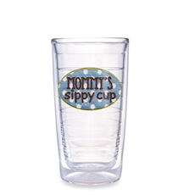](http://www.bedbathandbeyond.com/1/1/69464-tervis-tumbler-mommys-sippy-cup-16-ounce-tumbler.html)

[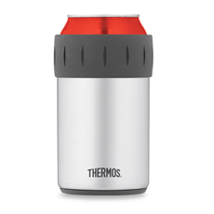](http://www.bedbathandbeyond.com/1/1/58818-thermos-vacuum-insulated-beverage-can-insulator.html)[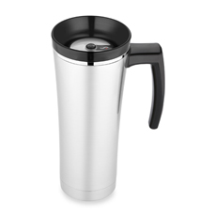](http://www.bedbathandbeyond.com/1/1/58809-thermos-sipp-vacuum-insulated-travel-mug-black.html)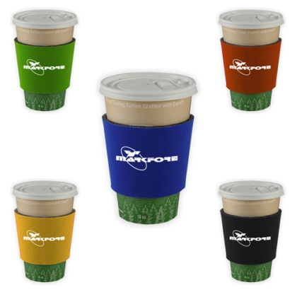

You have been hired by a thermos manufacturing company to conduct research into the development of the best materials to use as insulators in their new designs.

Heat transfer occurs via conduction when heat is passed by vibration of particles.

Your task is to compare two types of materials as possible insulators for the company to use in their new products.

Your conclusion will include the scientific reasons why the suggested material would be the best insulator for the company to use.

Ref. pg 109-110 in Pearson 9

Name:_______________________________ Class:__________________

Due Date: ____________________________

|  |  |  |  |
| --- | --- | --- | --- |
| **Part** | **Details** | **Available**  **mark** | **Your**  **mark** |
| Title | Descriptive NOT Physics Investigation | 1 |  |
| Aim |  | 1 |  |
| Hypothesis | Correctly worded  Includes dependent and independent variables | 2 |  |
| Variables | Independent  Dependent  Controlled | 4 |  |
| Materials | Complete  Listed | 2 |  |
| Method | Step by step with numbers  Written in past tense  Complete  Labelled Diagrams  Explain how reliable results are achieved | 1  1  1  2  2 |  |
| Results | Table - neat & clear with units | 3 |  |
| Graph | Showing two cooling rates over time for both type of material tested  Includes Title, labels on each axis, correct units, regular spaced, legend for each line graph | 5 |  |
| Discussion | Errors  Effects of errors  Solutions | 1  1  1 |  |
| Conclusion | What did the results show ?  Use figures from your results  Does this support your hypothesis?  Suggest best insulator type for use –give Scientific reasons | 1  1  1  3 |  |
| **Total mark** | | **34** |  |